Toolkit for Service Managers, Key Workers and other staff: supporting an adult with their needs assessment or review

What is the toolkit?

This toolkit is designed to support Service Managers, Key Workers and other staff with assessments and reviews for people who are living in residential care homes or supported living settings.

Who this toolkit is for?

This toolkit is for Service Managers, Key Workers and other staff who work in residential care homes or supported living settings.

What is the toolkit for?

The toolkit is intended to help Service Managers, Key Workers and other staff supporting people in residential care homes or supported living settings to prepare and participate in assessments and reviews where an adult’s care package may not be sufficient to meet their needs.

The needs assessment is the core process within the adult social care system. A good assessment that includes all the adult's needs and focuses on their wellbeing will provide the foundation for a sufficiently funded care package that allows the adult to live the life that they choose. However, if the assessment is not done correctly, an adult may not get the care and support they have a right to.

A review ensures that the care package meets the adult’s needs and highlights where further action is required. A review can prevent an adult's situation deteriorating and ensure that any changes needed to a care package are made in a timely way.

This toolkit helps you get the best outcomes for the adult whom you support, before, during and after the assessment or review process.

When might you need to request a needs assessment or a review?

Here are some examples of when it might be necessary to make this request:

- The adult's care package is not working well
- Funding is inadequate
- The adult is not able to pursue the things that they want to achieve
- The person's needs have changed e.g. their health has deteriorated
- The way the care and support are delivered is not flexible enough for the adult
- A family situation has changed e.g. a relative who is very involved in the adult's life has moved away
- Behaviours of distress are impacting on others in the placement, or the placement is at risk

The Care Act 2014 lays out how assessments and reviews should take place. The accompanying guidance gives details about what local authorities must and should do to make sure that these important processes result in the provision of the right care and support for the adult.
This toolkit guides you through the steps you need to take to support the adult through a needs assessment or review and to make sure that the Care Act is followed.

Remember that the person who needs care and support should always be central to these actions – where possible we have included Easy Read and video resources to help with these discussions.

This toolkit is divided into four stages:

Stage 1: | Requesting a review or a new needs assessment
Here we give you tips about when to ask for a review or assessment, and the most effective way of making that request. It includes links to template letters you can use for this purpose.
Stage 2: | Preparing for an assessment or a review
This section gives you a set of tasks you can do to prepare effectively and comprehensively for a review or assessment. Completing these tasks will make sure you have all the information you need at your fingertips during the assessment or review itself.
Stage 3: | The assessment or review meeting
This section includes tips on how the meeting should be conducted, and what you need to do to get the best outcome for the adult.
Stage 4: | After the assessment or review meeting
Here we give information about what should happen after the meeting and how you can follow up if there are delays or the outcome is not right for the adult.

At each stage you will find worksheets to help you prepare, videos and factsheets to help you gain a deeper understanding of the process, Easy Read material to support the adult to understand and engage in the process and template letters you can use to email requests and to remind the local authority of their duties under the Care Act. Case examples which are based on cases brought to Access Social Care with some fictionalised details help to illustrate typical issues you might face.

The legal quotations in the text below come from the Care Act 2014, the Care and Support Statutory Guidance and the Care and Support (Eligibility Criteria) Regulations 2015.

Stage 1: requesting a review or a new needs assessment

We know that some people wait for significant periods for a needs assessment or review. If the adult you are supporting needs an assessment or review promptly, it is important to know the most effective ways to make this request.

In February 2022, half a million people in England were waiting for an assessment or review or waiting for their care to start.
A good way to make an effective request for an assessment or review is to know what the law says the local authority should do. The following table gives you some tips, backed up by what the law says, as well as case examples, and then links to resources that can help you to make this request effectively.

Top tips | What the law says | Helpful resources
Tip 1 - Request a review or new assessment, making it clear where you believe that there has been:  - a change in the person’s needs  - or another change that affects the support plan, for example a void in service or a change affecting shared care  Note that in these cases a full new assessment may be needed. | Care Act s.27 (1) A local authority must - (a) Keep under review generally care and support plans that it has prepared, and (b) on a reasonable request by or on behalf of the adult to whom a care and support plan relates, review the plan.  Care Act s.27 (4) Where a local authority is satisfied that circumstances have changed in a way that affects a care and support plan, the authority must - (a) to the extent it thinks appropriate, carry out a needs assessment and [make an eligibility decision] and (b) revise the care and support plan accordingly. | Download a template for requesting a review from the local authority (download letter)
Tip 2 - If there is a need for urgent additional support then you should emphasise this in your request. Explain any safeguarding risks to health and safety in the absence of the additional support.  Note that the local authority must consider putting in urgent services whilst waiting for a full assessment when an appearance of urgent need comes to its attention. | Care and Support Statutory Guidance 13.34 The review should be performed as quickly as is reasonably practicable. As with care and support planning, it is expected that in most cases the revision of the plan should be completed in a timely manner proportionate to the needs to be met. Where there is an urgent need to intervene, local authorities should consider implementing interim packages to urgently meet needs while the plan is revised.  Care Act s.19 (3) - A local authority may meet an adult’s needs for care and support which appear to be urgent (regardless of whether the adult is ordinarily resident in its area) without having yet— (a) carried out a needs assessment or a financial assessment, or (b) made a determination under section 13. | Letter to request urgent support pending a needs assessment (download letter)
Tip 3 – If the response from the local authority takes too long or does not address the person’s needs sufficiently, then you can:  - Make a complaint  - Raise a safeguarding concern if the person is at risk as a result of the absence of additional support  - Seek legal advice | Care and Support Statutory Guidance 13.19 If there is any information or evidence that suggests that circumstances have changed in a way that may affect the efficacy, appropriateness or content of the plan, then the local authority should immediately conduct a review to ascertain whether the plan requires revision. For example this could be where a carer is no longer able to provide the same level of care, there is evidence of a deterioration of the person’s physical or mental wellbeing or the local authority receives a safeguarding alert. | Letter to make a complaint about social care  Letter to raise a safeguarding concern  If you wish to seek legal advice, you can search for solicitors near you on the Legal Aid Agency website. Enter your postcode and tick the Community Care box.  The law firm will let you know if the person is eligible for legal aid. If they are not eligible for legal aid you may be able to get advice elsewhere.
Tip 4 - Learn about an adult’s rights during reviews and assessments | Care Act s.27 (2) makes it clear that in deciding whether to revise a care and support plan, the local authority must have regard to the same things as when carrying out a needs assessment including, the impact on the adult’s need for care and support on their wellbeing, the outcomes they wish to achieve in their day to day life and whether and if so to what extent the provision of care and support could contribute to the achievement of those outcomes. | Factsheet on reviews and new assessments  Easy Read on reviews and new assessments
Tip 5 - When you are requesting a review or a needs assessment, you should keep a paper trail of your requests.  Follow up at regular intervals if you don’t hear back. The timing of the follow up will depend on the urgency of the case. | How we work  When one of our member organisations contacts us here at Access Social Care about a delay in completing a review or a needs assessment, one of the first things we will ask for is details of when the request for a review or needs assessment was first made and when this has been chased. If we need to send a formal legal letter to the local authority, we use this information to evidence the delay. | Worksheet 1: Paper trail
Tip 6 - You should check when the last review / assessment was carried out by the local authority (LA) and make it clear if this was more than a year ago. | Care and Support Statutory Guidance 13.32 - It is the expectation that authorities should conduct a review of the plan no later than every 12 months.
Tip 7 - Be clear about the impact of problems with their care package on the individual or any others in the service.  For example, they may not be able to access the community, they are being cared for in bed due to lack of funding for 2 to 1 for hoisting, they are not being able to join activities with others in the service behaviours of distress may be worse when they have less 1 to 1 support, resulting in risk of physical harm, or noise disturbance to other residents.  Try to link these impacts to the statutory outcomes and to their wellbeing. | Care manager feedback:  “I have used some of the terminology today in an email to the local authority and within a couple of hours I had secured 2:1 funding which was what was needed.” | Worksheet 2: documenting the impact of problems with the current care package
Tip 8 - If your organisation is over-delivering on the contract make this clear –  from what date, what additional services are being provided, what is the cost of these additional services,  what are the risks if not provided?  Include any supporting evidence regarding the urgency of addressing this. For example, incident reports, medical letters, and safeguarding referrals. This is important to ensure that more urgent cases are prioritised properly, and requests are not just dealt with in date order. | Case example:  Peter and his wife Pauline lived in a bungalow with a small package of care. The bungalow came under the registration of a care home. When Pauline died it became clear that Peter needed more care as he was having frequent falls. Laura, the registered manager, contacted the duty social work team and informed them that there was a vacancy in the same cluster with 24-hour staffing which he could move to temporarily whilst a full needs assessment took place. Shortly afterwards he moved to the other bungalow before additional funding had been agreed with the local authority due to safeguarding concerns. Four months later, the local authority completed a needs assessment which confirmed that the new placement was suitable, and that Peter wished to remain there. During discussions about costings for the new placement, the student social worker moved on, and the case was not reallocated. The care provider was still being paid on the basis of the original care package. At that stage, Laura referred the case to Access Social Care and we wrote to the local authority on Peter’s behalf. The local authority agreed to pay the increased fees for the new placement and backdate them to the date of the move, 12 months earlier. This was possible because Laura had kept evidence that she had provided the relevant information to the local authority at each stage. | Worksheet 3: documenting what you are currently over-delivering

Stage 2: prepare for a review or a new needs assessment

Preparing for an assessment can seem daunting but remember that the main purpose of any assessment is simply to find out more about the adult and their needs. Local authorities have to make budget savings of millions of pounds, so the clearer you can be to help them understand their level of need, the better. This means that preparation really pays off and makes a big difference to the outcome.

Steps to take | What the law says and how we work | Helpful resources
Step 1 - Get a copy of the latest documents from the local authority, for example the individual's latest:  - assessment  - review  - care plan  If the person lacks capacity to request this themselves, remember that if there is no-one with formal authority to act on behalf of the person, information should still be disclosed if it is in the best interests of the individual. | Care Act s.12 (3) 'The local authority must give a written record of a needs assessment to -  (a) the adult to whom the assessment relates,  ... and  (b) any other person to whom the adult asks the authority to give a copy'  s.25 (9): 'The local authority must give a copy of a care and support plan to -  (a) the adult for whom it has been prepared  ... and  (b) any other person to whom the adult asks the authority to give a copy'  Mental Capacity Act code of practice 16.19 ‘Healthcare and social care staff may disclose information about somebody who lacks capacity only when it is in the best interests of the person concerned to do so, or when there is some other, lawful reason for them to do so.’ | Legal information chatbot  Factsheet on mental capacity
Step 2 - Go through the documents and make notes of any changes, mistakes or gaps. Is there any support which you are providing or you believe is needed which is not included in the current support plan? | Care manager feedback  "So far your advice has been really helpful. I was more confident at the meeting and I felt better prepared on what I wanted to say particularly the impact on our gentleman.” | Worksheet 4: identifying gaps in the documentation
Step 3 - Identify the outcomes which the adult wishes to achieve in day-to-day life. | Care and Support Statutory Guidance 1.1- The core purpose of adult care and support is to help people to achieve the outcomes that matter to them in their life... Underpinning all of these individual ‘care and support functions’ (that is, any process, activity or broader responsibility that the local authority performs) is the need to ensure that doing so focuses on the needs and goals of the person concerned. | Factsheet on eligible needs  Easy Read document on assessments  Video on social care outcomes  Worksheet 5: identifying outcomes
Step 4 - Go through the statutory outcomes and find examples where the person is unable to achieve an outcome without significant difficulty or support.  Remember that support might be about prompting the adult to remember a task, or where the adult needs supervision while performing a task. | The Care and Support (Eligibility Criteria) Regulations 2015, regulation 2  (2) The specified outcomes are—  (a) managing and maintaining nutrition;  (b) maintaining personal hygiene;  (c) managing toilet needs;  (d) being appropriately clothed;  (e) being able to make use of the adult’s home safely;  (f) maintaining a habitable home environment;  (g) developing and maintaining family or other personal relationships;  (h) accessing and engaging in work, training, education or volunteering;  (i) making use of necessary facilities or services in the local community including public transport, and recreational facilities or services; and  (j) carrying out any caring responsibilities the adult has for a child.  NB The Care and Support (Eligibility Criteria) Regulations 2015, regulation 2  (3) For the purposes of this regulation an adult is to be regarded as being unable to achieve an outcome if the adult -  (a) is unable to achieve it without assistance;  (b) is able to achieve it without assistance but doing so causes the adult significant pain, distress or anxiety;  (c) is able to achieve it without assistance but doing so endangers or is likely to endanger the health or safety of the adult, or of others; or  (d) is able to achieve it without assistance but takes significantly longer than would normally be expected.  (4) Where the level of an adult’s needs fluctuates, in determining whether the adult’s needs meet the eligibility criteria, the local authority must consider the adult’s circumstances over such period as it considers necessary to establish accurately the adult’s level of need. | See pages 12-17 of our needs assessment information pack for more detailed guidance on the specified outcomes.  Worksheet 6: the statutory outcomes  Video 1 on eligibility
Step 5 - Think about the impact on wellbeing. How would being unable to achieve the outcomes that you have worked through in step 4 affect the adult? | Care Act section 1  (1) The general duty of a local authority, in exercising a function under this Part in the case of an individual, is to promote that individual’s well-being.  (2)“Well-being”, in relation to an individual, means that individual’s well-being so far as relating to any of the following -  (a) personal dignity (including treatment of the individual with respect);  (b) physical and mental health and emotional well-being;  (c) protection from abuse and neglect;  (d) control by the individual over day-to-day life (including over care and support, or support, provided to the individual and the way in which it is provided);  (e) participation in work, education, training or recreation;  (f) social and economic well-being;  (g) domestic, family and personal relationships;  (h) suitability of living accommodation;  (i) the individual’s contribution to society.  (3) A local authority must have regard to the following matters in particular -  (a) the importance of beginning with the assumption that the individual is best placed to judge the individual’s well-being;  (b) the individual’s views, wishes, feelings and beliefs;  (c) the importance of preventing or delaying the development of needs for care and support or needs for support and the importance of reducing needs of either kind that already exist;  (d) the need to ensure that decisions about the individual are made having regard to all the individual’s circumstances (and are not based only on the individual’s age or appearance or any condition of the individual’s or aspect of the individual’s behaviour which might lead others to make unjustified assumptions about the individual’s well-being);  (e) the importance of the individual participating as fully as possible in decisions relating to the exercise of the function concerned and being provided with the information and support necessary to enable the individual to participate;  (f) the importance of achieving a balance between the individual’s well-being and that of any friends or relatives who are involved in caring for the individual;  (g) the need to protect people from abuse and neglect;  (h) the need to ensure that any restriction on the individual’s rights or freedom of action that is involved in the exercise of the function is kept to the minimum necessary for achieving the purpose for which the function is being exercised. | Video 2 on eligibility  Factsheet on eligibility  Worksheet 7: wellbeing
Step 6 - Remember there is no hierarchy of needs – recreation and maintaining relationships is as important as personal care or safeguarding. | Care and Support Statutory Guidance 1.6 - The individual aspects of wellbeing or outcomes above are those which are set out in the Care Act and are most relevant to people with care and support needs and carers. There is no hierarchy, and all should be considered of equal importance when considering ‘wellbeing’ in the round. | Worksheet 8: relationships and aspirations
Step 7 - Focus in particular on any needs for 1:1 and 2:1 support and how shared support works in practice.  Is there a clear breakdown in the support plan? Who is support shared with? Is it possible to meet all the needs within the shared support?  Consider whether:  - a whole service review is needed  - changing the shared care staff ratio would be an alternative to providing 1 to 1 support | Case example:  We received an enquiry from a service manager about a young man, Graham, who needed personal care. Graham shared his support with a housemate who then moved out. The local authority stopped paying for the support worker that Graham had shared with his former housemate, and the supported living service was expected to manage with two out of the three staff assigned. Graham did not like to go out, and so this meant his remaining housemates also had to stay at home instead of taking part in their usual activities outside the home. This was effectively a cut to the service for all the adults who lived there. Access Social Care supported the manager to argue for the additional support that was needed. | Worksheet 9: shared support
Step 8 - Think about fluctuating needs and whether a contingency plan is needed. When might additional support be required? | Care and Support Statutory Guidance 10.44 For example, the person may have fluctuating needs, in which case the plan should make comprehensive provisions to accommodate for this, as well as indicate what contingencies are in place in the event of a sudden change or emergency. This should be an integral part of the care and support planning process, and not something decided when someone reaches a crisis point. | Worksheet 10: fluctuating needs
Step 9 - Check that your own support plans and incident reports are up to date and include relevant information. | A care manager’s thoughts  ‘Up and down the country people’s rights are not being upheld. There is a clear disregard of  the Care Act by local authorities.  Furthermore, the lack of understanding from individuals about their rights means that local  authorities can get away with it, so they hide behind finances and budgets but neglect  people’s right to access services and the right support.’
Step 10 - Check whether the current fee is adequate. If in doubt, do real costings of the support you provide to the individual for comparison. | Case example:  Barbara has lived at her care home, run by Chrysanthemum Care for 30 years. The funding for new residents receiving the same level of care is much higher. Part of the review process considers whether the ‘personal budget’ is still sufficient to meet the care needs of the individual. Prior to the review meeting, the Chrysanthemum Care service manager works with his colleagues in the finance team to cost the support currently being provided. This shows a significant shortfall. The costings are provided during the review process and the local authority agrees to increase Barbara’s personal budget so that it covers the actual cost of the placement. | Worksheet 11: checking current fees
Step 11 – Where appropriate, involve family / advocate so they are aware of the issues prior to the meeting.  For example,  - ask them for their comments on current assessment / care and support plan,  - share any of your concerns/ideas with them. | Case example:  Angela lives in a residential care home and had attended a day service her whole adult life. She has found meaningful activities and close friendships there. During Covid-19 the local authority removed the day service from her care plan, as she had not been considered a priority due to the fact that she lived in a care home, and they considered this important service that promoted her relationships and wellbeing as 'double-funding'. The care manager arranged for Access Social Care to support Angela and her family to get the day service reinstated in her care plan. | Worksheet 12: family and advocate comments

Stage 3: the assessment or review meeting
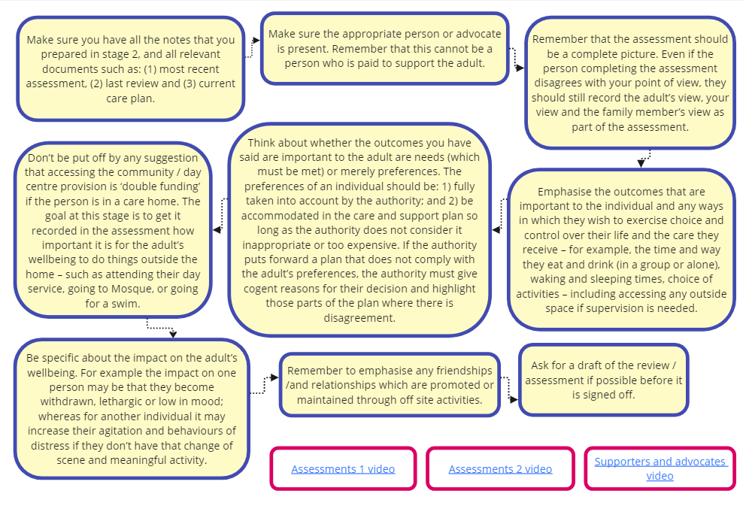
Stage 4: after the assessment or review meeting
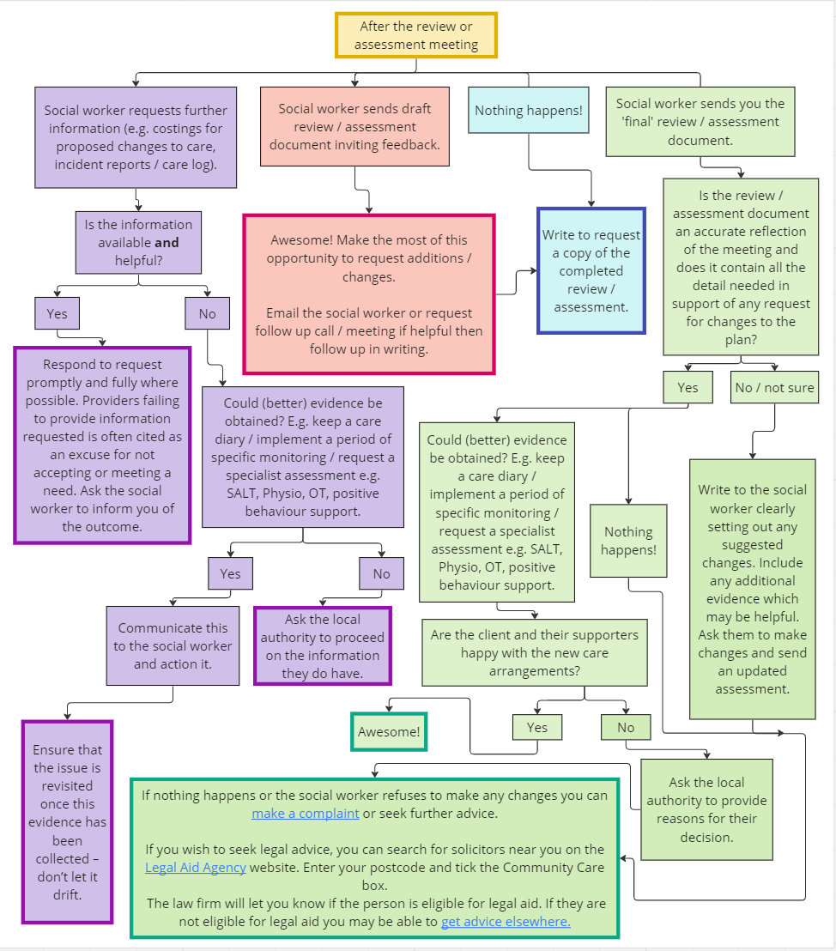

Worksheet 1: paper trail

Keep copies of emails

Date | Phone/Email/Meeting | Who was involved? | What was discussed?
31.8.23 | Phone call | Adult social care call centre staff, manager of service. | Asked if a review had been scheduled for G. Call handler said they would get a social worker to phone back.

Worksheet 2: documenting the impact of underfunding

Outcome | What does [name] feel is the impact of not having enough support? | What additional observations do you have about the impact on [name] of not having enough support? | What is the impact of not having enough support on others in the service?
Managing and maintaining nutrition | G would like to be able to cook independently so that he can entertain his girlfriend. | G forgets to eat regularly and can go for a whole day without making a meal. | G has quite a restricted diet and because there is not enough support to make different meals with everyone, others have to eat the same restricted diet.
Maintaining personal hygiene

Managing toilet needs

Being appropriately clothed

Being able to make use of the adult's home safely
Maintaining a habitable home environment
Developing and maintaining family or other personal relationships
Accessing and engaging in work, training, education or volunteering
Making use of necessary facilities or services in the local community including public transport, and recreational facilities or services
Carrying out any caring responsibilities the adult has for a child

Worksheet 3: documenting what you are currently over-delivering

When did your organisation begin over-delivering on the contract?
What additional services are you providing?
What is the cost of providing these services?
What are the risks of not providing these services?
What supporting evidence do you have to show why you need to provide this additional support?
e.g.
- Incident reports
- Medical letters
- Safeguarding referrals
- Other (please describe)

Worksheet 4: identifying gaps in the documentation

Care and support that [name] needs that is not described in the documentation | We are currently providing this care and support  (yes/no)
G needs prompting support to get ready for his volunteering role on a Monday, Wednesday and Friday. | yes

Worksheet 5: identifying the outcomes that [name] wants to achieve
It is very important for G to see his cousin every week

Worksheet 6: the statutory outcomes

Outcome | Why is the outcome not met? E.g. [name] can’t do this without support; causes anxiety distress or pain; prompting required; activity takes much longer | How would [name] like the need to be met?  How might this prevent needs from increasing?
Managing and maintaining nutrition (describe which part of the outcome cannot be met here)
Maintaining personal hygiene (describe which part of the outcome cannot be met here)
Managing toilet needs (describe which part of the outcome cannot be met here)
Being appropriately clothed (describe which part of the outcome cannot be met here) | e.g. G is unable to judge what is appropriate to wear at different times. | G likes to plan what he will wear that week with his key worker, and then he can follow the plan himself.
Maintaining a habitable home environment (describe which part of the outcome cannot be met here)
Making use of the home safely (describe which part of the outcome cannot be met here)
Developing and maintaining family and other personal relationships (describe which part of the outcome cannot be met here)

Worksheet 7: wellbeing

Wellbeing area | Examples
Personal dignity | G has to wear pads between home care visits. He says he feels ashamed of this and he avoids having visitors as a result.
Physical and mental health and emotional well-being

Protection from abuse and neglect

Control by the individual over day-to-day life (including over care and support, or support, provided to the individual and the way in which it is provided)
Participation in work, education, training or recreation

Social and economic well-being

Domestic, family and personal relationships

Suitability of living accommodation

The individual's contribution to society

Worksheet 8: thinking about relationships and aspirations

Here you can log relevant information about what is important to the person when it comes to these areas of their lives.

Family and friends

Community activities and travel

Work, training and volunteering

Looking after a child

Worksheet 9: thinking about shared support

Here you can log information about how much shared support is in place and how well it works.

1:1 / 2:1 support is needed for the following activities:

Shared support can work for the following activities:

Support is shared with:

Problems with shared support:

Worksheet 10: fluctuating needs

[name] needs more support when…

[name] can manage with a lower level of care and support when…

Worksheet 11: checking current fees

Check whether the current fee is adequate. If in doubt, do real costings of the support you provide to the individual for comparison.

Day | Hours of support | Hourly rate x hours of support | Hotel costs if relevant | Contingencies | Other expenses | Totals
Monday
Tuesday
Wednesday
Thursday
Friday
Saturday
Sunday
Weekly totals

Worksheet 12: family and advocate views

Person consulted | Date | Views

If you have used this toolkit, we would really appreciate it if you could complete our two-minute survey to help us improve it!

Access Social Care annual audited report 2021

